**Wire-Frame Design**

**STORES SALES PREDICTION**

|  |  |
| --- | --- |
| Written By | Ganesh Sayaji Thorat |
| Document Version | 1.0 |
| Last Revised Date | 10-09-2021 |

**Document Change Control Record:**

|  |  |  |  |
| --- | --- | --- | --- |
| **Version** | **Date** | **Author** | **Comments** |
|  |  |  |  |
|  |  |  |  |
|  |  |  |  |
|  |  |  |  |
|  |  |  |  |
|  |  |  |  |
|  |  |  |  |
|  |  |  |  |
|  |  |  |  |
|  |  |  |  |
|  |  |  |  |
|  |  |  |  |
|  |  |  |  |
|  |  |  |  |
|  |  |  |  |
|  |  |  |  |

**Reviews**

|  |  |  |  |
| --- | --- | --- | --- |
| **Version** | **Date** | **Reviewer** | **Comments** |
|  |  |  |  |

### **Approval Status:**

|  |  |  |  |  |
| --- | --- | --- | --- | --- |
| **Version** | **Review date** | **Reviewed By** | **Approved By** | **Comments** |
|  |  |  |  |  |

**API Home Page:** On the API homepage the user will be able to see the details of API i.e., parameters that have to pass as json data also URL of API call.

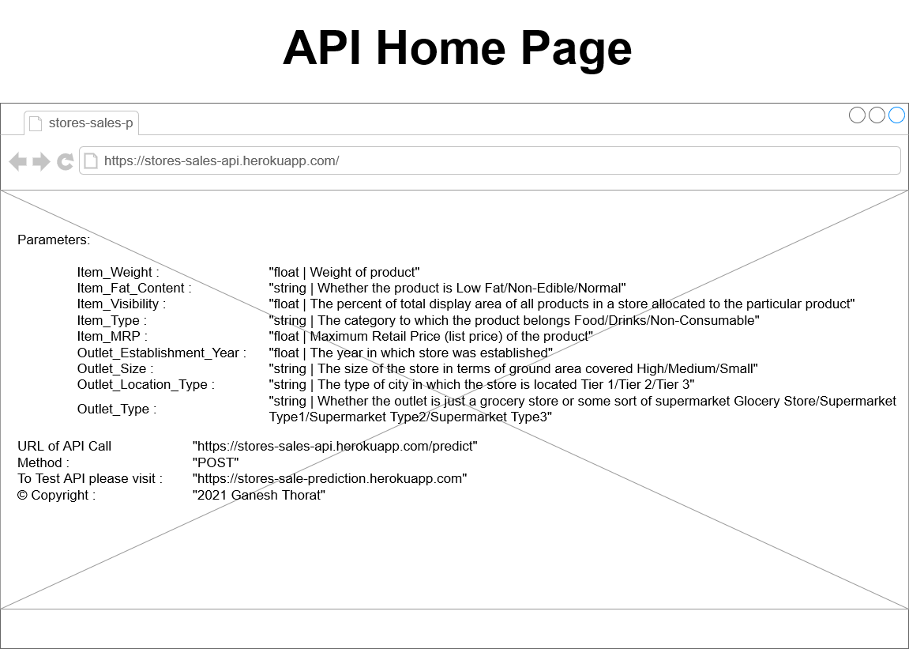

**Webapp Home page:** On the homepage the user will be able to see the heading of the project name. And there will be inputs which user needs to give.

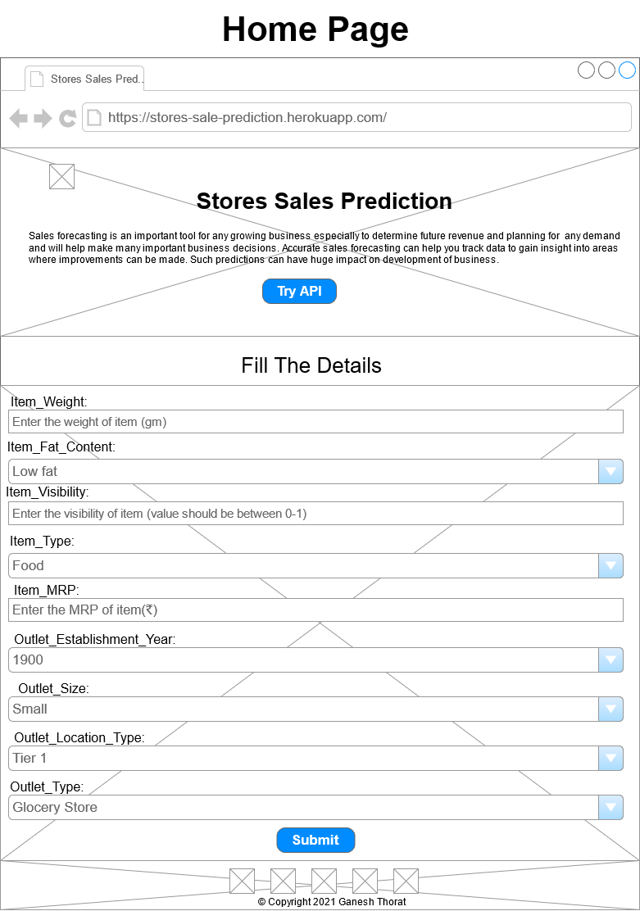

**Prediction Page:**

After the user will give inputs there will be predict button, on clicking predict button the next page will open which will be the result page where the prediction will be shown at the bottom for the given inputs. Below is the image how the result page will look like:

